lOMoARcPSD|24935341

# Network design proposal for Hospital

A COURSE PROJECT REPORT

*Submitted By*

**Aryan Mohan Shukla(RA2111028010160)**

**Shrajoy Sur (RA2111028010182)**

**Amaan Sabir(RA2111028010185)**

**Under the guidance of**

**Dr. P. VISALAKSHI**

(Assistant Professor Department of Computing Technologies)

*In partial fulfillment of the requirements for the*

*Course of*

18CSS202J – COMPUTECOMMUNICATIONNS

In

Networking And Communication

 With specialization in Cloud Computing

**FACULTY OF ENGINEERING AND TECHNOLOGY SRM INSTITUTE OF SCIENCE AND TECHNOLOGY**

**Kattankulathur, Chengalpattu District**

**603203**

MAY 2023

**SRM INSTITUTE OF SCIENCE AND TECHNOLOGY**

**(UnderSection3ofUGCAct,1956)**

# BONAFIDE CERTIFICATE

# Certified that this mini project report "Network design proposal for Hospital" is the bonafide

# *work of* Aryan Mohan Shukla (RA2111028010160) ,Shrajoy Sur (RA2111028010182),

# Amaan Sabir(RA2111028010185) who carried out the project work under mysupervision.

**SIGNATURE SIGNATURE**

Dr. P. VISALAKSHI DR.ANNAPURANI PANAIYAPPAN

Assistant Professor Head of the Department

Department of Computing Technologies Department of Networking and Communication SRM Institute of Science and Technology SRM Institute of Science and Technology

**ACKNOWLEDGEMENT**

We express our heartfelt thanks to our honorable **Vice Chancellor Dr. C. MUTHAMIZHCHELVAN**  for being the beacon in all our endeavors.

We would like to express our warmth of gratitude to our **Registrar Dr. S.Ponnusamy,** for his encouragement

We express our profound gratitude to our **Dean (College of Engineering and Technology)Dr.T.V.Gopal,** for bringing out novelty in all executions.

We would like to express our heartfelt thanks to Chairperson , School of Computing **Dr. Revathi Venkataraman,** for imparting confidence to complete our course project

We wish to express our sincere thanks to **Course Audit Professor Dr. Annapurani Panaiyappan ,Professor and Head of Department Networking and Communications** and **Course Coordinators** for their constant encouragement and support.

We are highly thankful to our Course project Faculty P.VISALAKSHI**, Assistant Professor, B-TECH,** for her assistance, timely suggestion and guidance throughout the duration of this course project.

Finally, we thank our parents and friends near and dear ones who directly and in directly contributed to the successful completion of our project. Above all, I thank the almighty for showering his blessings on me to complete my Course project.

**TABLE OF CONTENTS**

|  |  |
| --- | --- |
| **S.NO.** | **CONTENTS** |
| **1** | ABSTRACT |
| **2** | PROJECT SCOPE |
| **3** | NETWORK REQUIREMENTS |
| **4** | NETWORK REQUIREMENT ANALYSIS (MAIN AND WARDS) |
| **5** | HARDWARE ANALYSIS |
| **6** | CONFIGURATION GUIDELINES |
| **7** | IP NETWORK DESIGN TABLE |
| **8** | NETWORK TOPOLOGY DIAGRAM |
| **9** | HARDWARE LIST WITH QUANTITY |
| **10** | NETWORK TESTING AND VERIFICATION. |
| **11** | CONCLUSION |

**ABSTRACT**

For the purposes of this research, the “design science” discipline of Information Systems will structure the overall methodology and framework for results. By leveraging the design science framework, this study will dissect and analyze various parts of a hospital’s network, to uncover substandard practices and problematic weaknesses that commonly result in an overall decrease in the quality of healthcare provided to patients, and negatively affect business operations of hospitals and healthcare facilities.

**Project Scope :**

A network proposal has to be designed for a hospital which has the following. There is a main block and three wards in the campus. The main block is the administrative block where registration of new patients takes place. The main block has 3 floors. The hospital has identified hospital management software, which should be accessible by the employees. The software is installed on a server at the administrative block. At the ground floor, there are 10 computers at the billing section. At other floors, there is one computer user each. The farthest distance between the computer on the top most floor and the ground floor is less than 70 meters. The wards have 3 floors each, with 5 computers in the gound floor of each ward. The distance between the wards and the blocks are less than 80 Meters. The computers in the wards may be increased based on future expansion plans.

The project aims to design a network for a hospital with one main block and three wards. The network should be capable of providing reliable and secure connectivity for the hospital management software to all employees. The network should also have the capability of dynamic IP addressing, be loop-free at Layer 2, and ensure easy access to the hospital management software from any location within the hospital.

**Network requirements**

1. Hardware requirement analysis in main block with quantity.  
2. Hardware requirements analysis in wards.  
3. The employees should receive dynamic IP addressing from a central server.  
4. Network should be loop free at Layer 2  
5. Every computer should be able to access the hospital management software from each of the location using a fixed IP address.  
6. IP Network design table.  
7. Identify configurations on the hardware wherever appropriate.  
8. Network topology diagram with necessary equipment’s

**Network Requirement Analysis (Main and Wards)**

* The hospital consists of one main block and three wards, with three floors each.
* The main block has the hospital management software installed on a server, which needs to be accessible to all employees.
* The ground floor of the main block has ten computers, while the other floors have one computer each. The farthest distance between the computer on the topmost floor and the ground floor is less than 70 meters.
* Each ward has five computers on the ground floor, with the distance between the wards and the main block being less than 80 meters.

**Hardware Requirements Analysis:**

Main Block:

* Router: A router is required to connect the hospital to the internet and manage the network traffic. One router is required.
* Switches: Switches are required to connect all the computers in the main block to the network. Three switches are required for each floor.
* Server: A server is required to host the hospital management software. One server is required.
* Computers: Ten computers are required on the ground floor, and three computers are required on each of the other floors.

Wards:

* Switches: Switches are required to connect all the computers in each ward to the network.
* One switch is required for each ward .
* Computers: Five computers are required on the ground floor of each ward.

**Configuration Guidelines:**

* Dynamic IP addressing should be implemented using DHCP.
* VLANs should be used to segregate network traffic between different departments and floors.
* Spanning Tree Protocol (STP) should be used to prevent network loops.
* The hospital management software should be hosted on the server with a fixed IP address accessible to all computers on the network.

**IP network design**

IP network design table for the proposed network design for a hospital:

|  |  |  |  |
| --- | --- | --- | --- |
| **Device** | **IP Address** | **Subnet Mask** | **Default Gateway** |
| ROUTER | 192.168.1.1 | 255.255.255.0 | N/A |
| SERVER | 192.168.1.2 | 255.255.255.0 | 192.168.1.1 |
| MAIN BLOCK | 192.168.1.100 -192.168.123 | 255.255.255.0 | 192.168.1.1 |
|  |  |  |  |
| WARD 1 | 192.168.1.124 -192.168.1.147 | 255.255.255.0 | 192.168.1.1 |
|  |  |  |  |
| WARD 2 | 192.168.1.148 –192.168.1.171 | 255.255.255.0 | 192.168.1.1 |
|  |  |  |  |
| WARD 3 | 192.168.1.172 –192.168.1.195 | 255.255.255.0 | 192.168.1.1 |

**NETWORK TOPOLOGY AND DIAGRAM**

For connecting the network for the Hospital we are selecting star topology .As Star topology is a type of network topology in which every device in the network is individually connected to a central node, known as the switch or hub. When represented visually, this topology resembles a star which gives it its name.

The Major reason to select star topology was:

* Easy to Install and Configure. Star topology is relatively easy to install and configure.
* Easy to Troubleshoot. Star topology is also easy to troubleshoot.
* Scalability. Star topology is highly scalable.
* Improved Performance
* High Security
* Single Point of Failure
* Cost efficient

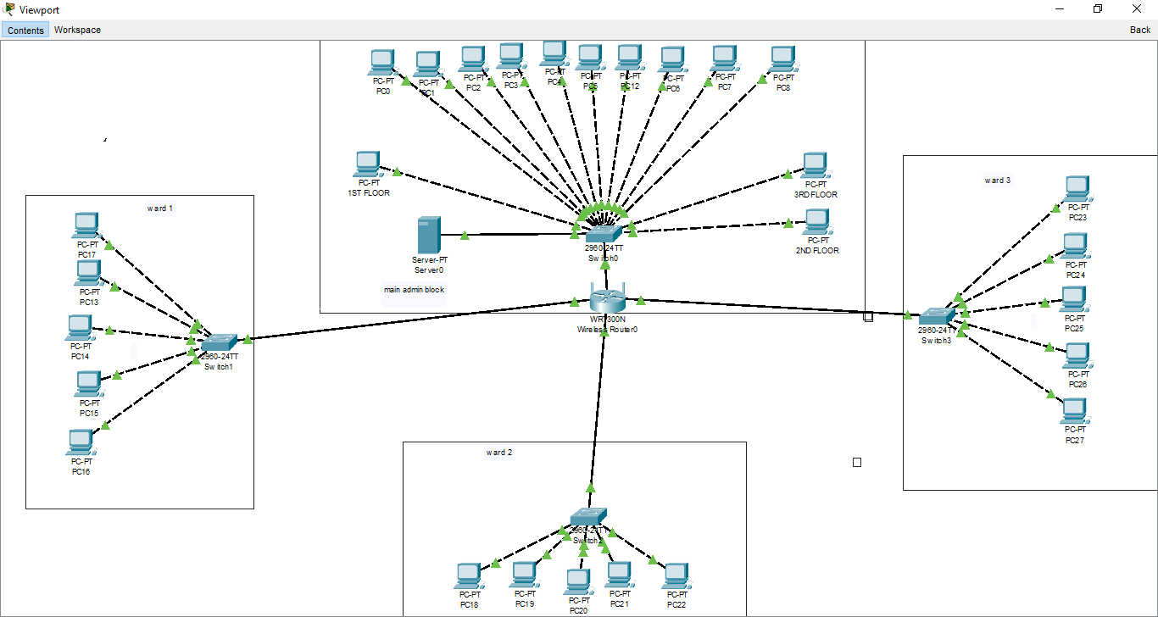

**Hardware List with Quantity:**

All the required hardware for creating network for the hospital are as follows:-

|  |  |  |
| --- | --- | --- |
| **S.NO.** | **DEVICE** | **QUANTITY** |
| 1. | Router | 01 |
| 2. | PC’s | 23 |
| 3. | Switch | 4 |
| 4. | Server | 1 |
| 5. | Copper Straight Through wire | As per requirements |
| 6. | Copper Crossover Wire | As per requirements |

**NETWORK TESTING AND VERIFICATION**:-

**-*Checking the network connection between server and router.***

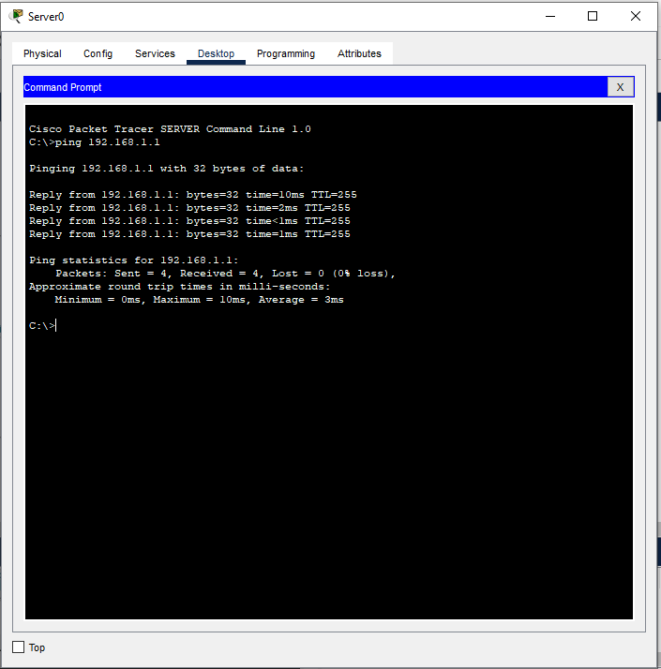

**-*Checking the connection of admin block system with file access to server.***

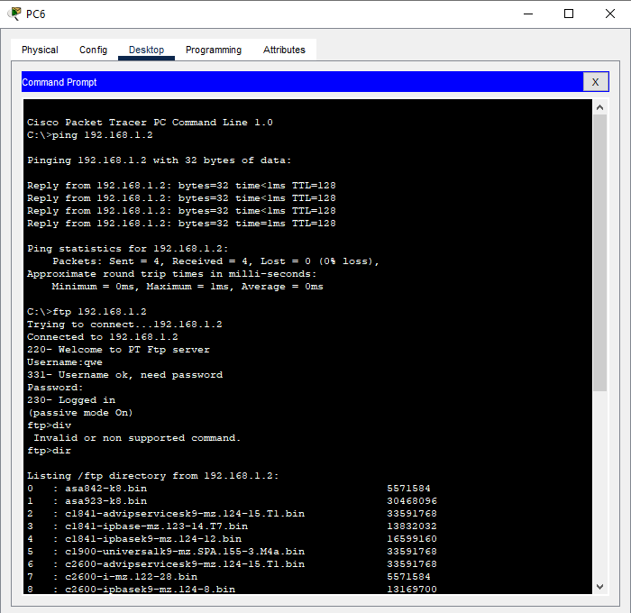

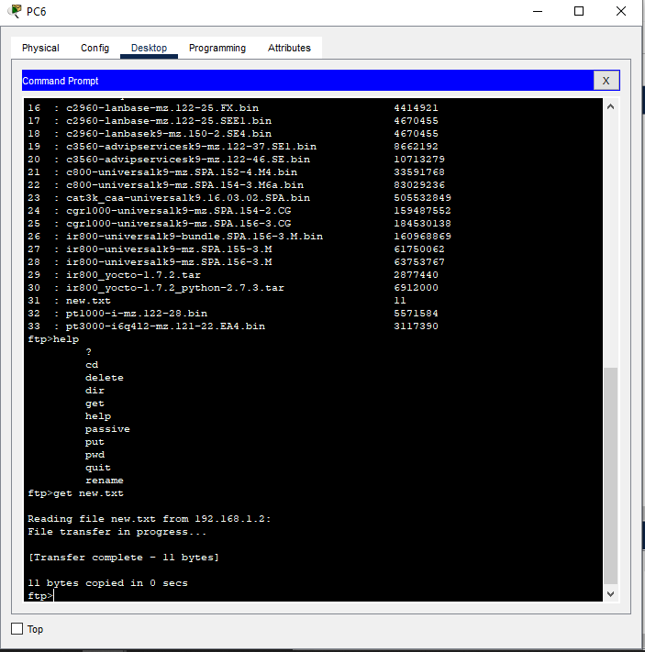

***-Checking network connection and file access of system on ward-1 to server***

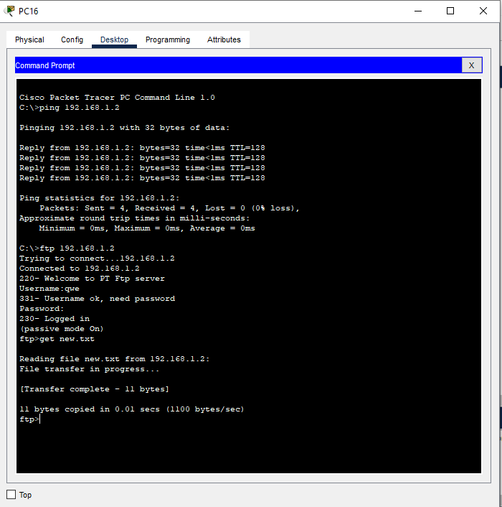

***-Checking network connection and file access of system on ward-2 to server***

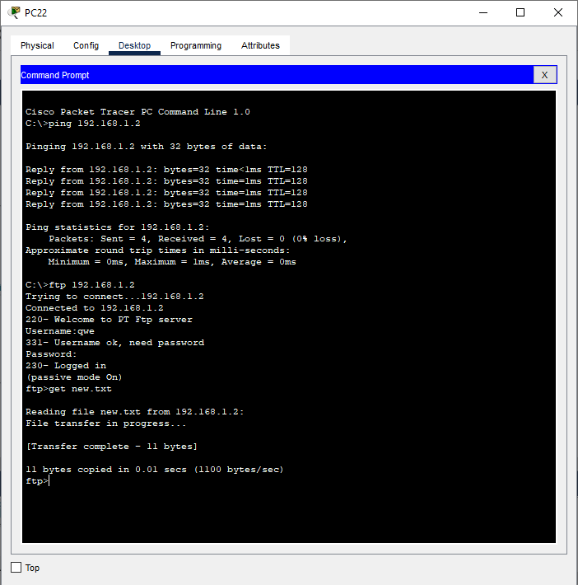

***-Checking network connection and file access of system on ward-3 to server***

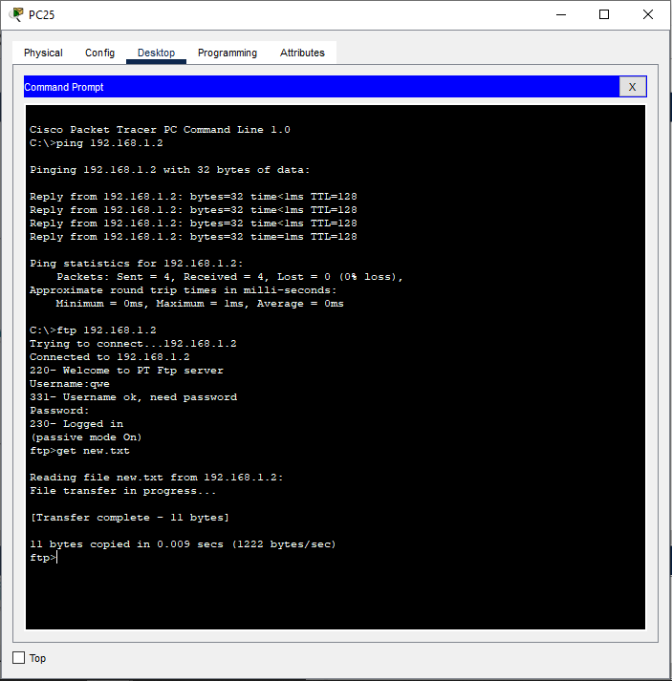

**Conclusion**

The proposed solution is designed to meet the requirements of the hospital l network while ensuring security and ease of management. It. Provides The network should be capable of providing reliable and secure connectivity for the hospital management software to all employees. The network should also have the capability of dynamic IP addressing, be loop-free at Layer 2, and ensure easy access to the hospital management software from any location within the hospital.The network is easy to manage using proper network management tools and techniques.